ABAP/4
ABAP Part II LAB BOOK

Table of Contents
Table of Contents 2
Getting Started 3
Lab 1-1 Module Pool Programming 4
Lab 2-1 Introduction to OOABAP 9
Lab 3-1 ALV and OOALV 15
Lab 4-1 File Handling 22

Getting Started

Overview
This lab book is a guided tour for learning SAP ABAP. It comprises of assignments to be done. Refer the demos and work out the assignments given by referring the case studies which will expose you to work with Java applications.

Setup Checklist for SAP ABAP
Here is what is expected on your machine in order to work with lab assignment.
Minimum System Requirements
- Intel Pentium 90 or higher (P166 recommended)
- Microsoft Windows 2010 or higher.
- Memory: (8GB or more recommended)

Please ensure that the following is done:
- SAP GUI is installed
- Connection to the SAP Server is present

Lab 1-1 Module Pool Programming
Goals | - Screen designing by using subscreens, tab strips, table controls and user defined transaction codes to update the data in the ztables.
Time | 4 Hrs.
Lab Setup | Connectivity to SAP server  Login details for connecting SAP server

- Create a simple module pool transaction to display the single material output.

Reference T-Codes and Tables:

T-Codes: SE38, SE51, SE93 and MM03 Tables: MARA.

Go to SE38 and SE51 T-Codes to create module pool program.
Step # 1: In the first screen accept the single material number from the user and when you click on the NEXT button the output should be displayed in the second screen. When you click on the EXIT FROM SCREEN button Leave from the screen.

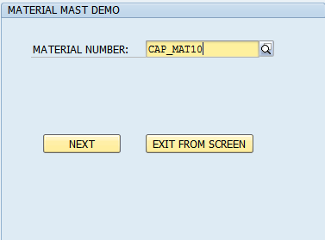

Step # 2: In the second screen display the single material output based on the input provided in the first screen and when you click on the BACK Button control should be back to first screen to modify the input of the material number. When you click on EXIT Button leave from the program.

MATERIAL NUMBER, IND SECTOR and MATERIAL TYPE Fields should be in display mode (Output fields) and user cannot edit the fields at runtime.

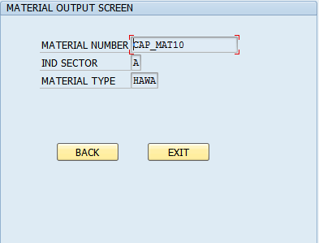

- Create a module pool program to display the table control output.

Reference T-Codes and Tables:

T-Codes: SE38, SE51, SE93 and MM03 Tables: MARA, MARC And MAKT.

Go to SE38 and SE51 T-Codes to create module pool program.
In the First Screen accept material range from the user and when you click on the NEXT pushbutton the output should be displayed in the second screen as a table control.

When you click on the EXIT button Leave from the screen.

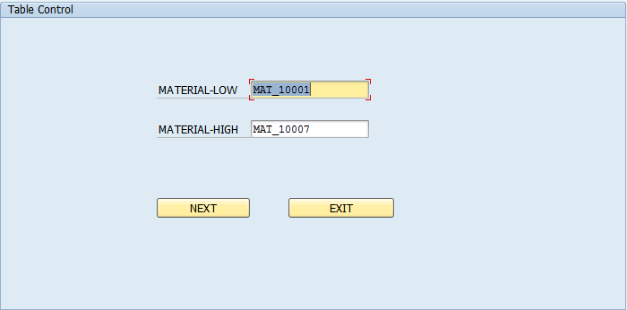

In the Second Screen When you click on the BACK TO SCREEN 100 push button, go back to the initial screen to modify the input of the material range. When you click on the EXIT push button leave from the program.

Table Control output should be in display mode user cannot be edit the fields at runtime.

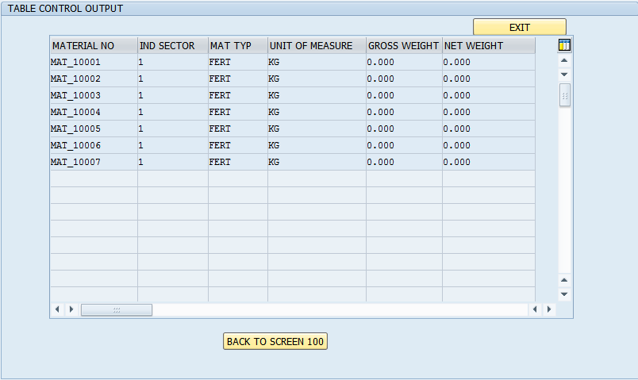

- Create a module pool program to display the tabstrip control output.

Go to SE38 and SE51 T-Codes to create module pool program.

Reference T-Codes and Tables:

T-Codes: SE38, SE51, SE93 and MM03 Tables: MARA.

Step # 1: In the first screen create the tabstrip control in TAB1 to accept the material range from the user and when you click on the TAB2 pushbutton the output should be displayed in the second screen as a table control format.

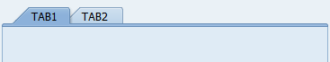
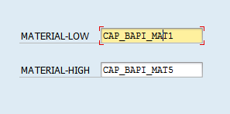

Step # 2: In the second screen, create table control and get the data from mara table based on the material range provided in TAB1.

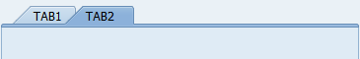
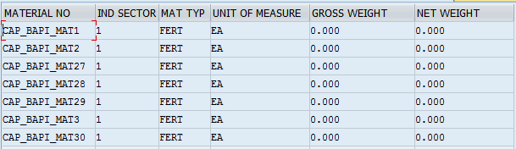

- Create a module pool program to work with ztable DML operations.

Go to SE38 and SE51 T-codes to create module pool program.

Reference T-Codes and Tables:

T-Codes: SE38, SE51 and SE93. Tables: zemp.

Design the module pool screen to update the zemployee table information.

Note: Select the Display/Maintenance Allowed with restrictions option under Delivery and Maintenance tab in the table (SE11) to prevent the data Load/Insert directly on to the table.

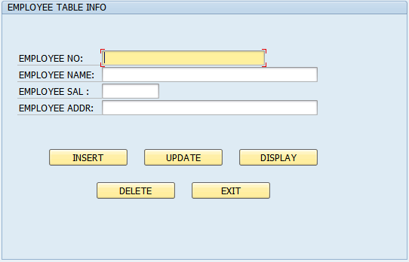

Lab 2-1 Introduction to OOABAP
Goals | - How to use the ABAP Objects using Global class.
Time | 4 hours
Lab Setup | Connectivity to SAP server  Login details for connecting to SAP server

- Create a global class having a method .Pass the data to the class from a Report.

Step # 1: Go to SE24 T-code and create a global class. In the class, create the instance method LIST_MATERIAL.
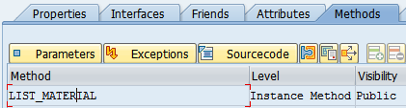

Step # 2: Declare the import and export parameters and click on the source code button to write the select query logic inside the method.(Logic:Select query fetches 10 fields from MARA table for the material range entered)
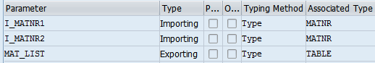

Step # 3: Go to SE38 T-Code and create a Report. Call the global class method LIST_MATERIAL.
- From the user,take the material number range by using the SELECT-OPTIONS for I_MATNR1 and I_MATNR2.
Eg: SELECT-OPTIONS S_MATNR FOR MARA-MATNR.
- Call the method of the global class and pass the material range to it.The class returns the material details in a table MAT_LIST.
- Display the material details as shown in the list below

For MAT_LIST Importing : Map the Internal table structre with the MAT_LIST.

CALL METHOD OBJ->LIST
EXPORTING
I_MATNR1 = S_MATNR-LOW
I_MATNR2 = S_MATNR-HIGH
IMPORTING
MAT_LIST = IT_TAB
EXCEPTIONS
MATERIAL_NOT_FOUND = 1

Expected output: OOABAP ALV grid display by using the custom container.

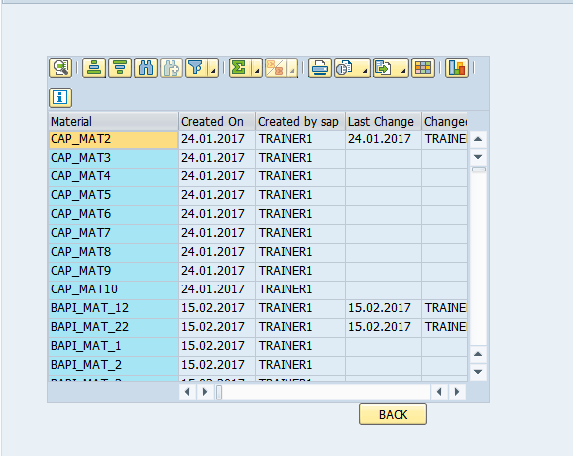
- Create constructor in a class and set the attributes using the constuctor.
- Create a local class with the following attributes.
Material Number
Industry Sector
Material Type
Base UOM
Gross weight
Net Weight

- The class must have a constructor which will set the value of the above attributes. Create a method DisplayMat which displays the above details. Also create two objects of the class.
Note: Do the above using Local class.
- Create a method to set and display the attributes of a class.
- Copy the above class and have a Method as SetMat(Instead of constructor) which sets the value of the attributes.
- Write down a method named DisplayMat which displays the above details. Also create two objects of the class.
Note: Do the above using Local and Global class.

- Create events and methods in a class and call the events from another class..
- Create two local classes which contains one method each.
Note: Class c1 contains the method m1 and class c2 contains the method m2.
- Class C1 contains the following attributes and method m1 sets the values of the same.
Material Number
Industry Sector
Material Type
Base UOM
Gross weight
Net Weight
- Create an event in class 2 which should trigger the method of class C1.
- Wrtie a program which creates the instance of Class C2 and triggers the above event.

- Create an event in a global class and call the event from a Report.

Step # 1: Go to SE24 T-code and create a global class with an event NO_CARRID.
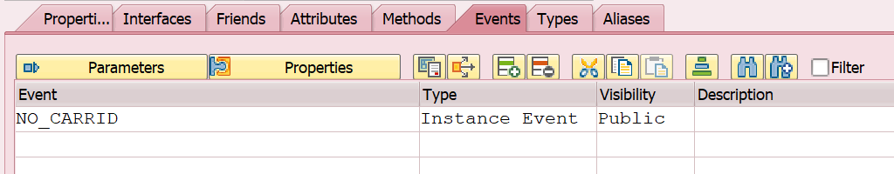

Step # 2: Create handler method NO_CARRID_HANDLER. Link the hander method to the event NO_CARRID. In the method NO_CARRID_HANDLER, give the message to be displayed when event is raised.

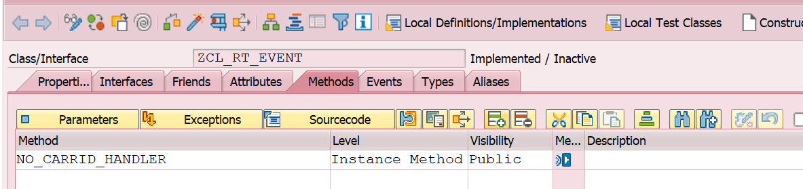

Step # 3: Declare another method GET_SFLIGHT_DETAILS. Give its import and export parameters and click on the source code button to write the select query logic inside the method. If the user enters the right carrid then display the Flight details else raise the event NO_CARRID.
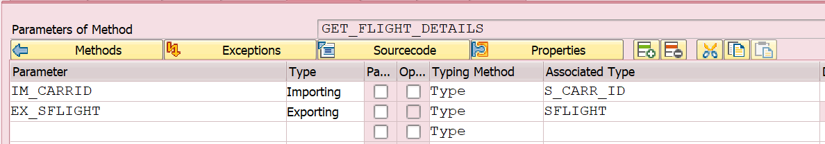

Step # 4: Go to SE38 T-Code create a report and accept CARRID as input from the user. Call the global class method GET_SFLIGHT_DETAILS. If the user does not enter CARRID then raise the exception NO_CARRID.

E.g.: PARAMETERS P_CARRID type CARRID.

CREATE OBJECT obj.
SET HANDLER obj->no_carrid_handler FOR obj.
START-OF-SELECTION.
CALL METHOD obj->get_sflight_details
EXPORTING
im_carrid = p_carrid
IMPORTING
ex_sflight = wa_sflight
Expected output: If no CARRID is entered by the user , then the expected output is :
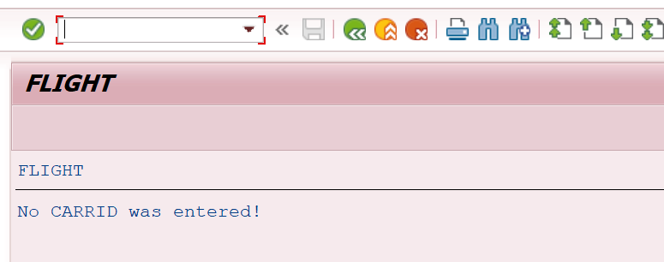

- Create an interface. Implement the interface in a global class. Call the methods of the interface from a local class.

Step # 1: Go to SE24 create an interface with method GET_FLIGHT_DETAILS .Interface has importing parameter CARRID and exporting parameter sflight structure.
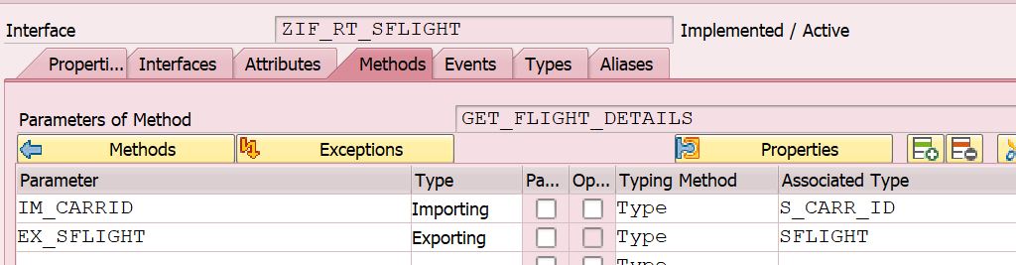

Step # 2: Go to SE24, create a global class. Add the interface ZIF_RT_SFLIGHT in the class.
Implement the method inside the class by writing the select query to fetch sflight details.Fetch details from table SFLIGHT for the entered CARRID.
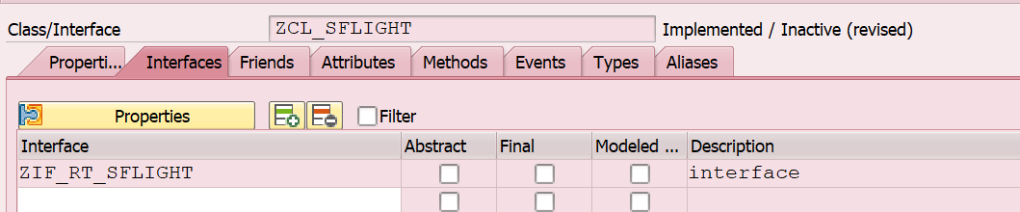
Step # 3: Declare another method GET_SFLIGHT_DETAILS. Give its import and exporting parameters and click on the source code button to write the select query logic inside the method

Step # 4: Go to SE38 T-Code and take as input CARRID from the user.Call the global class method GET_FLIGHT_DETAILS to display the flight details.
E.g.: PARAMETERS P_CARRID type CARRID.

CREATE OBJECT obj.
START-OF-SELECTION.
CALL METHOD obj->zif_rt_sflight~get_flight_details
EXPORTING
im_CARRID = p_carrid
IMPORTING
ex_sflight = wa_sflight.
Expected output: If CARRID is entered by the user, then the output will contain the SFLIGHT details from table SFLIGHT.

Lab 3-1 ALV and OOALV

Goals | - How to use normal ALV (ABAP List Viewer) and OOALV (Object Oriented ALV) Report Attributes, Methods, Events and Containers.
Time | 8 Hours
Lab Setup | Connectivity to SAP server  Login details for connecting to SAP server

- Create an ALV Grid Display with LOGO.

Create an executable program to prepare the range of materils list with LOGO and LIST Heading by using ALV Grid display.

Program Logic Hints:

- Declare the Internal table types with ref to ALV SLIS_T_FIELDCAT_ALV , SLIS_T_LISTHEADER, SLIS_LAYOUT_ALV and SLIS_T_EVENT.
- Use the function modules REUSE_ALV_GRID_DISPLAY and REUSE_ALV_COMMENTARY_WRITE
- Upload the LOGO By using the T-Code OAER and prepare the LIST Heading with the SLIS_T_LISTHEADER properties.

Reference T-Codes and Tables:

T-Codes: SE37, OAER and MM03. Tables: MARA, MARC and MAKT .

Step # 1. Go SE38 T-Code and creat an executable program and the Input should be Materials range and it should be an obligatory.

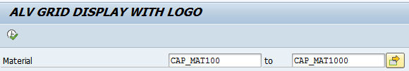

Step # 2. The expected report output should be as shown in the below screen.

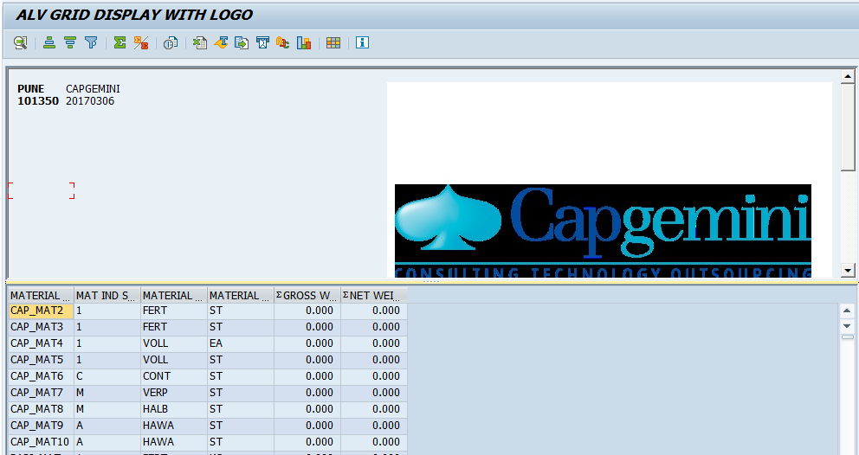

- Develop an ALV Hierarchical Sequential list display report.

Create an executable program to prepare the range of flight details by using ALV Hierarchical display.

Program Logic Hints:

- Declare the Internal table types with ref to ALV SLIS_T_FIELDCAT_ALV , SLIS_LAYOUT_ALV and SLIS_KEYINFO_ALV.
- Use the function module REUSE_ALV_HIERSEQ_LIST_DISPLAY.

Reference Tables:

Tables: SFLIGHT ,SCARR

Step # 1. Go to SE38 T-Code and create an executable program .Take the Airline codes as input from user.(Airline code is CARRID from table SFLIGHT)

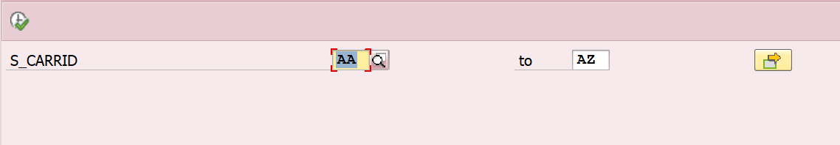

Step # 2. The expected output must be drill down output as shown in the below screen.

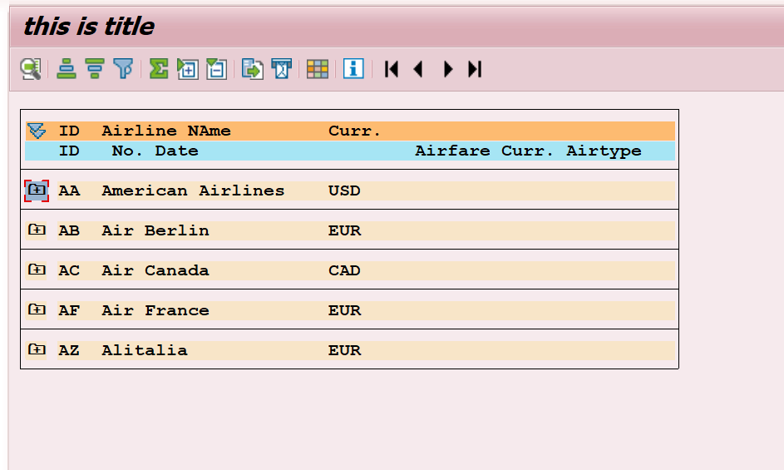

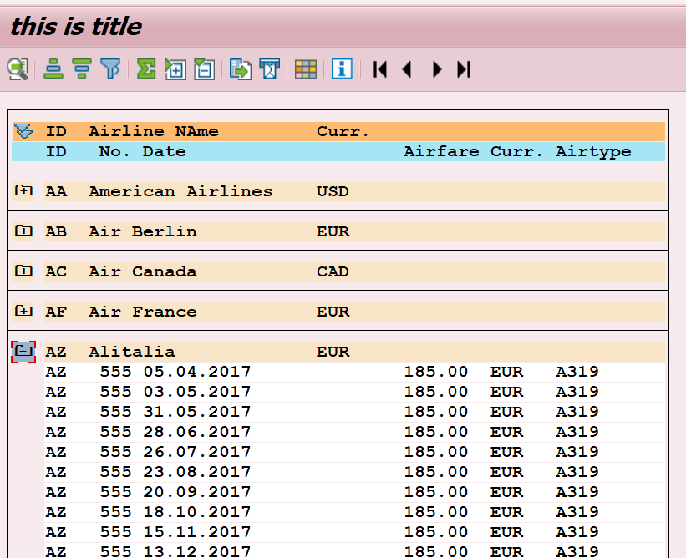

- Create an OOALV Interactive report by using EVENT handling method with pushbutton in the toolbar.

Display the Material details in OOALV Interactive report by using the custom container.

Program Logic Hints:
- Declare the Containers.
Use the CL_GUI_CUSTOM_CONTAINER and CL_GUI_ALV_GRID Containers.

- Declare the EVENT handling Method. METHODS METH1 FOR EVENT USER_COMMAND OF CL_GUI_ALV_GRID IMPORTING E_UCOMM
- METHODS METH2 FOR EVENT TOOLBAR OF CL_GUI_ALV_GRID IMPORTING E_OBJECT

Reference T-Codes and Tables:

Tables:MARA and MARC

Step # 1. Go SE38 T-Code and create an executable program . Input should be Material
No.
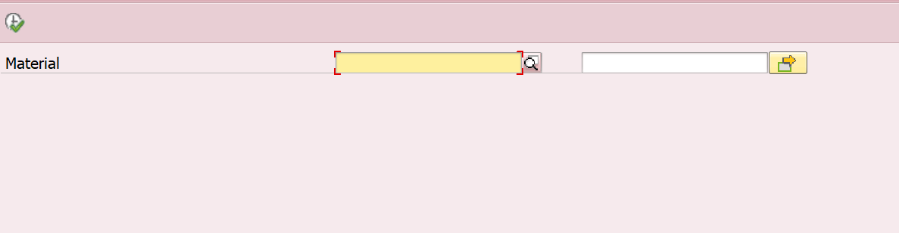

Step # 2. Output of the report should contain the Material details fields from table MARA.The ALV should have a button called GET_PLANT_DETAILS in the tool bar.

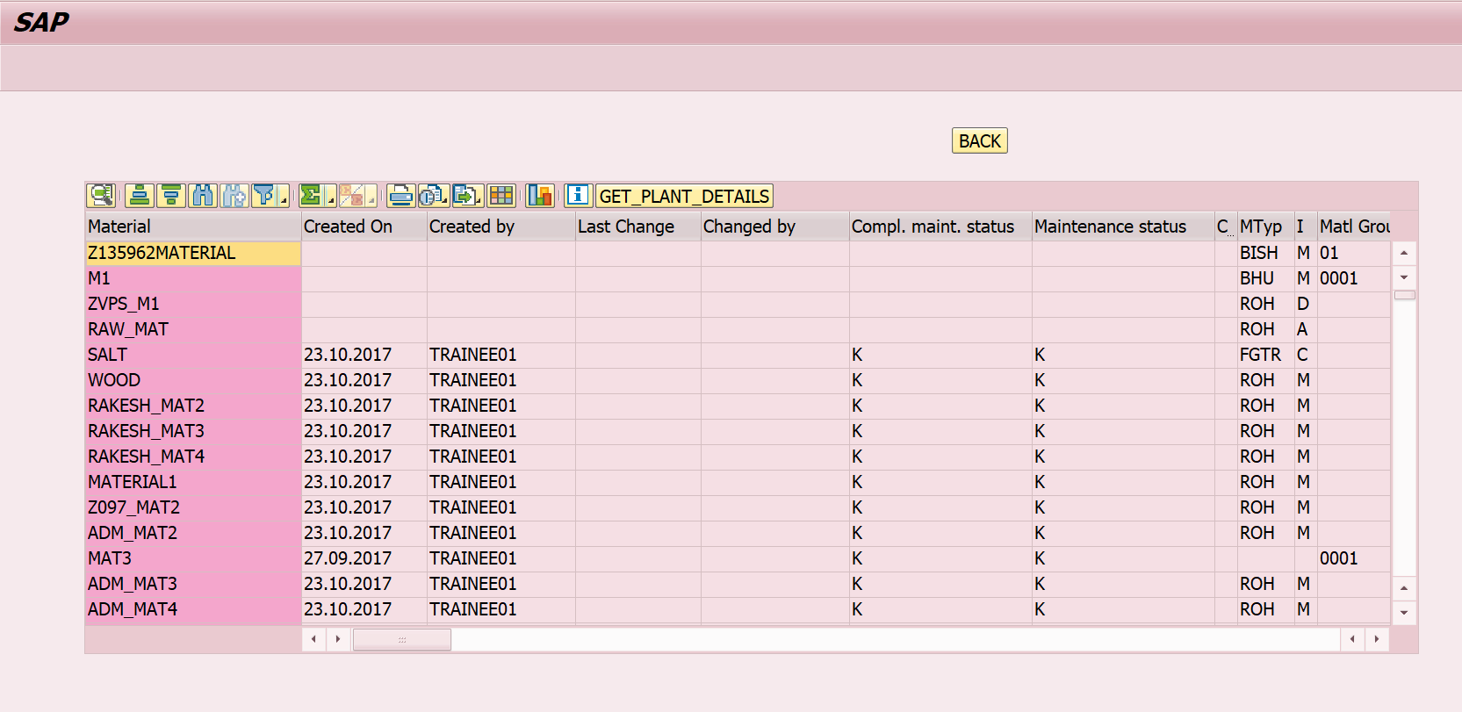

Step # 3. On clicking the button GET_PLANT_DETAILS, details of the plant from table MARC should be displayed.(Display the Plant details for all the materials entered by the user.)
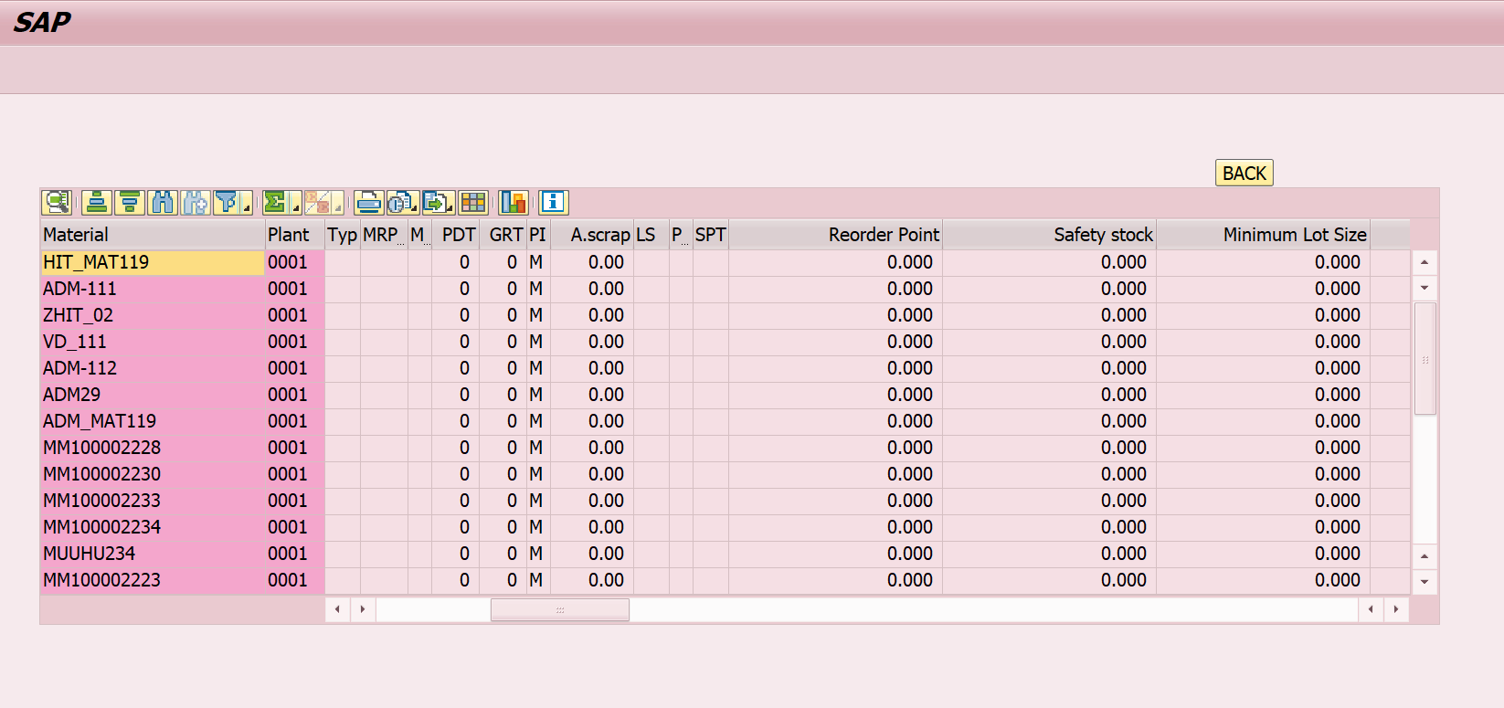

- Create an OOALV Interactive report by using EVENT handling method.

Display the Purchase Order OOALV Interactive report by using the custom container.

Program Logic Hints:
- Declare the Containers.
Use the CL_GUI_CUSTOM_CONTAINER and CL_GUI_ALV_GRID Containers.

- Declare the EVENT handling Method. METHODS METH1 FOR EVENT DOUBLE_CLICK OF CL_GUI_ALV_GRID IMPORTING E_ROW

Reference T-Codes and Tables:

Tables: SFLIGHT and SCARR

Step # 1. Go SE38 T-Code and create an executable program . Input should be Airline Code range 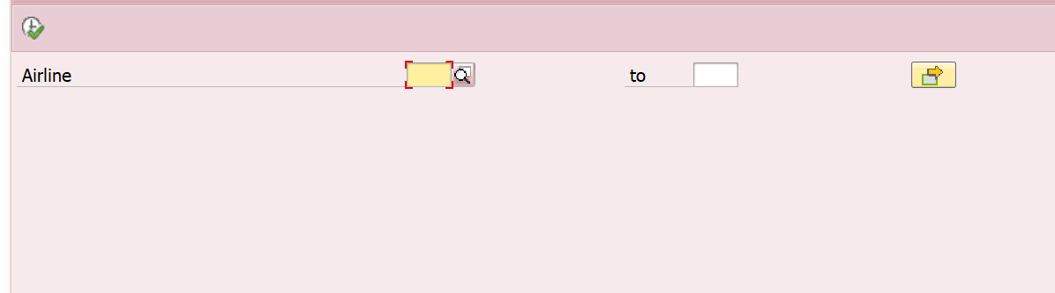

Step # 2. Output of the report should contain the fields from the table SCARR as shown below.(Fetch flight details from table SCARR for the CARRID entered by the user)
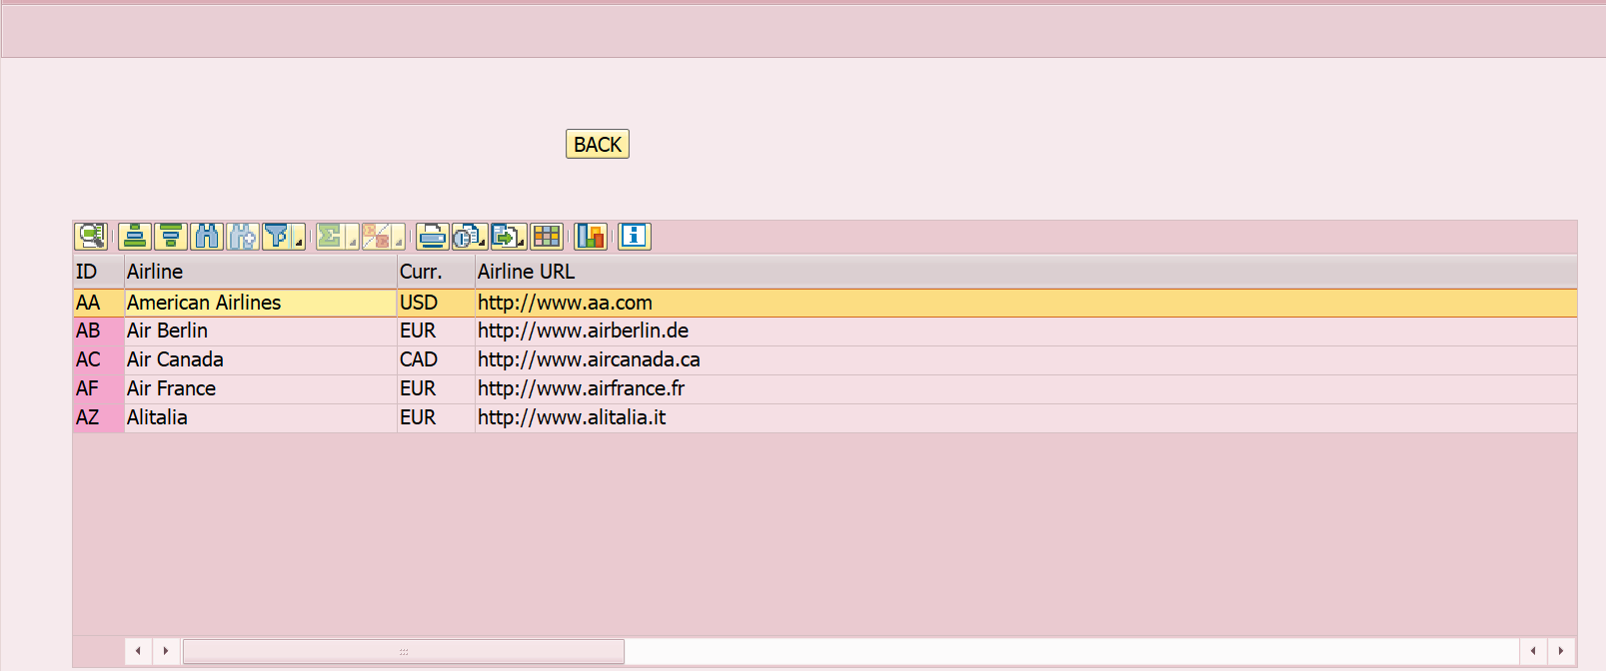

Step # 3. If the user selects (Double clicks) on any row then display the details from table SFLIGHT for the Airline Code as shown below.

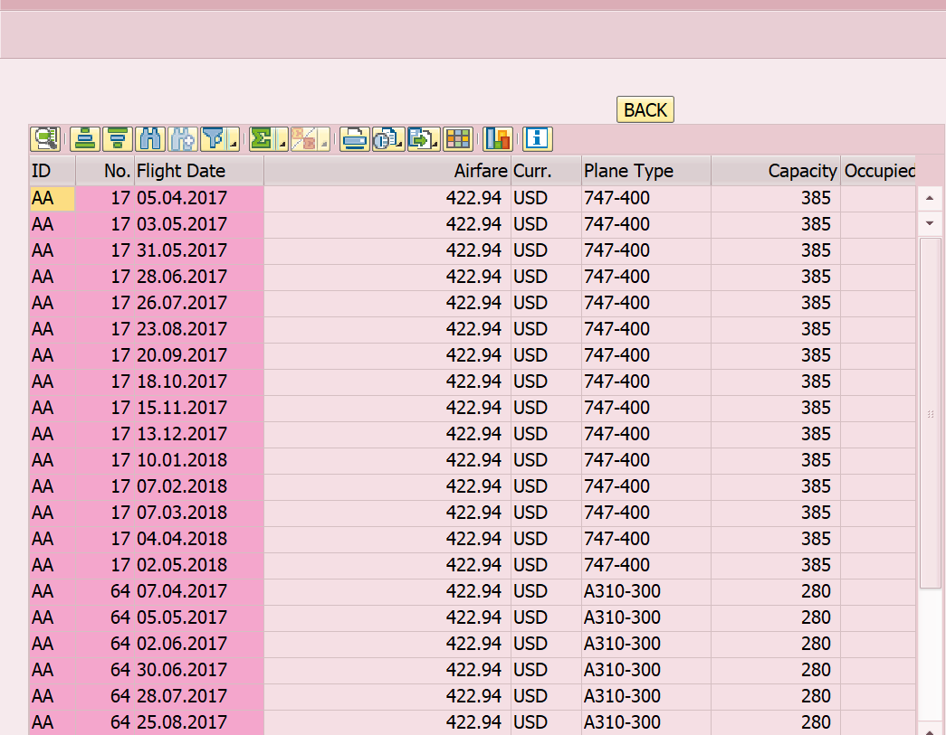

Lab 4-1 File Handling
Goals | - How to use the file handling and data upload through the BDC Session Method by using the File Handling.
Time | 120 Minutes
Lab Setup | Connectivity to SAP server  Login details for connecting SAP server

Reference T-Codes:

T-Codes: AL11 and CG3Z.

Refer the Application Server Path:

Go to AL11 T-Code and click on the below path to find out the physical files in the application server.

Path 1:

Path 2:

- File Uploading.

Write an executable program to read the attaced file from the presentation server(GUI_UPLOAD) and upload it on to the Application Server for a specific path (Ref; the above path 1 to check the files in application server after upload). Eg: D:\usr\sap\LND\DVEBMGS00\work\CAP_MAT1

- File Downloading.

Write an executable program to download (GUI_DOWNLOAD) the file from the Application Server to Presentation Server for a specific path.
Eg:C:\Users\adm-ig-hwdlab2e\Desktop\MAT_MAST.TXT.

- File Appending.

Write an executable program to read the attaced file from the presentation server(GUI_UPLOAD) and upload it to an existing file path on to the Application Server. (Ref; the above path 1 to check the files in application server after upload). Eg: D:\usr\sap\LND\DVEBMGS00\work\CAP_MAT1.

- Data upload through BDC Session Method by using the File Handling.

Step # 1.Write an executable program to upload the proper new material master file (file name Eg.Mat_Mast.txt) from the presentation server and upload it on to the Application Server.

Step # 2.Write a BDC Session method program to upload the new material master data for MM01 T-code and file should be read from the application server (I.e: File Name placed with the step # 1) .

Step # 3. Process the BDC session method by using the SM35 T-code and check the materials status in MM03 T-Code and Check the entries in MARA, MARC and MAKT tables.

